**PIR – PASSIVE INFRA-RED MOTION SENSOR**

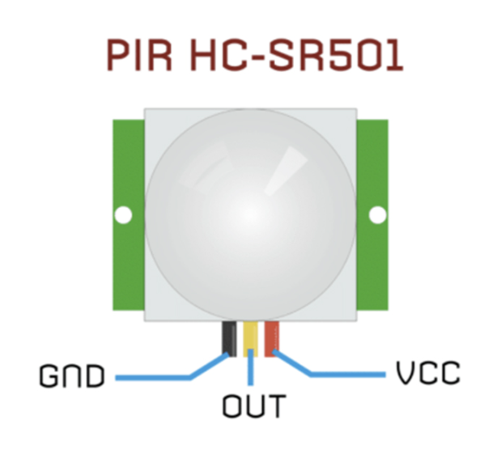

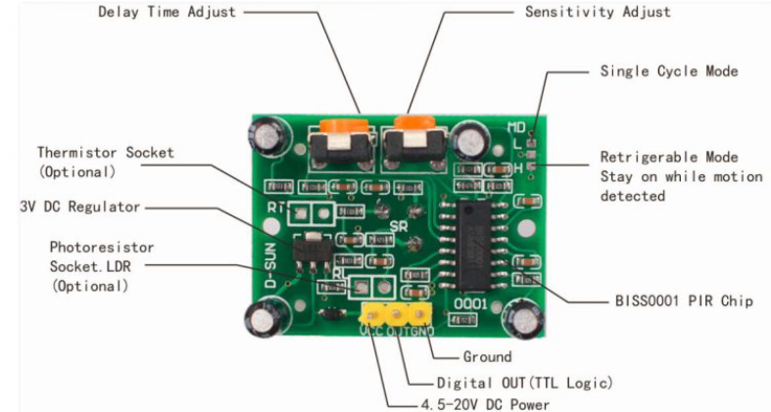

|  |  |
| --- | --- |
| **Pin or Control** | **Function** |
| Delay Time Adjust | Sets how long the output remains high after detecting motion…. Anywhere from 5 seconds to 5 minutes. |
| Sensitivity Adjust | Sets the detection range…. from 3 meters to 7 meters |
| Ground pin | Ground input |
| Digital Output Pin | Low when no motion is detected. High when motion is detected. High is 3.3V |
| Power Pin | 4.5 to 20 VDC Supply input |
|  |  |

Sensitivity Control

|  |  |
| --- | --- |
| H Setting – Sensor will go high when a person is detected, and will stay high for a set duration. After which it will go low    I Setting – Sensor will go high when a person is detected, and will stay high for as long as the person stays within its sensing range | Off time Control |
|  |

Reading Material:

<https://components101.com/sensors/hc-sr501-pir-sensor>

<https://www.teachmemicro.com/raspberry-pi-pico-hc-sr501-motion-sensor/>